Try working on the file(pregnant.data) present in the path(C:\Users\rrmamidi\Desktop\old Desktop\compress_1\python\meachin learning doc\data files\Datasets-master) to know which age persons got number of pregnant.

Formulas for linear regression:-

Y axis = distance

X axis = speed

Y= mx+c

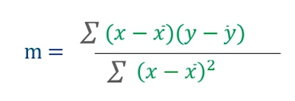

1. X bar Value will be (1+2+3+4+5)/5
2. Y bar value will be (3+4+2+4+5)/5

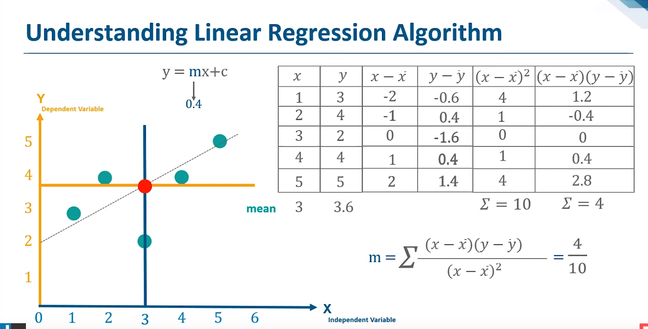

Predicted value of y ()will be calculated as below.

